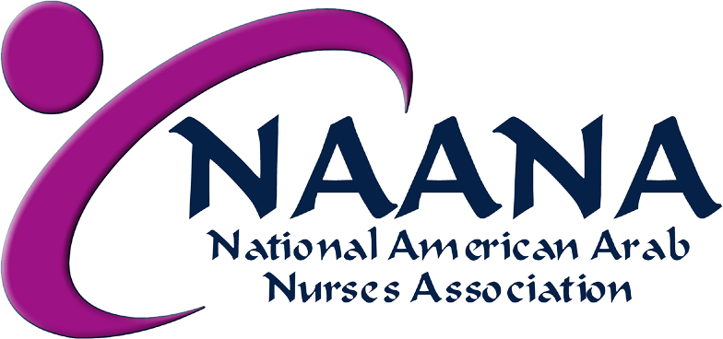

NURSING SCHOLARSHIPS AVAILABLE!
The National American Arab Nurses Association (NAANA) is pleased to announce its annual scholarships, awarded to the most meritorious applicants who are engaged in studying nursing at the Associate Degree, Bachelor Degree, RN-BSN, or BSN-MSN (master’s in nursing) levels. Annually $500 to $1000 scholarships are awarded, depending on the funds available in a given year. The scholarships should be applied toward tuition and/or books in the academic year they are awarded.
Do you qualify?
- Applicants must provide proof of acceptance or enrollment in an accredited nursing program at the time of application.
  - Applicants must be of Arab heritage, citizens or permanent residents of the United States, and must reside within the US or its territories.
      - Academic excellence, exemplified by achievement of a grade point aver- age [GPA] of 3.0 [on a 4-point scale] or its equivalent.
        - Demonstrated leadership (academic, professional, and/or through student organizations).
          - Evidence of engagement in and contribution to the health care of the Arab American community.

NAANA
Nursing Scholarship Applications Due
June 30, 2019

The 2019 scholarships will be presented at NAANA’s Angel of Mercy Dinner.

For additional information, visit us at www.n-aana.org or http://n-aana.org/scholarship.html

